

**Mrs. Summerville’s**

**2nd Grade Class 2020-2021**

Email: msummerville@paulding.k12.ga.us

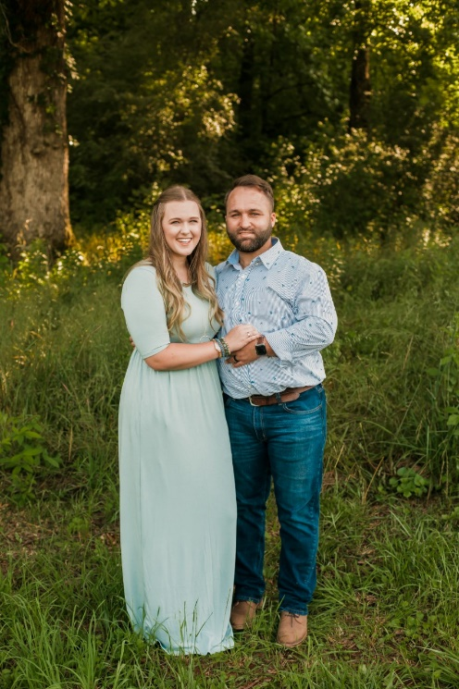

Welcome to second grade! My name is Megan Summerville. This is my first year teaching. I graduated from the University of West Georgia in December with Summa Cum Laude, which is the highest honors. I have experience at Sharp Creek Elementary, Carrolton Elementary, Haralson County Elementary, Glanton-Hinsman Elementary and Whitesburg Elementary. I have worked with a variety of children throughout my experience by student teaching, observing and Substitute teaching. These students even include Special Education students, as my degree is for Early Childhood, as well as Special Education. I have been married for 2 and ½ years to Micky Summerville who is a band director, and I have two dogs, which I consider my babies. When I am not at school, I love spending my time with my family and friends, painting and hiking. I am very excited to be working with you this year! I adore children and will care for and love my students as if they are my own!